Deployment Document

The work provided in this guide is for use at “own risk”, and AWS and its affiliates cannot be held responsible. Customers are encouraged to test this in their development instance as a starting point.

This is an installation guide for accelerating adoption of Amazon EMR Clusters by utilizing the *AWS Service Catalog connector for ServiceNow* v1.6.7. New versions can be utilized as well but have not been tested.The “update sets” provided in this section build upon the basic capabilities of the AWS Service Catalog connector. With the upgrade, you will be able to do the following:

1. Schedule a time to provision an Amazon EMR Cluster
2. Schedule a time to automatically terminate an Amazon EMR Cluster
3. Schedule can be one-time schedule or a recurring schedule. For example, as a user I can provision an EMR cluster that terminates at 5pm or I can schedule a cluster that comes up every day at 8 AM and terminate at 5pm for a specified period.

## Prerequisite:

This guide is an ***advanced*** guide for an architect that is familiar with the below already:

1. *AWS Service Catalog connector for ServiceNow*
2. Amazon Service Catalog
3. Have an Amazon EMR cluster in AWS Service Catalog already and able to provision and terminate using the base capabilities of the *AWS Service Catalog connector for ServiceNow.* If you have EC2 instances with the connector, you can use this guide. A single EC2 instance is the simplest version of an EMR Cluster

## Good to know!

* The instance does not get provisioned automatically after the approval of the scheduled provisioning request; instance will always get provisioned on the selected time by the user.
* Functionality has been enhanced to work 24 hours, with 1hr gap time-frame. Any time can be selected for provisioning and termination of the instance that is present in the choice list.

## Installation Instructions

* Before uploading the new functionality to your instance, make sure you have installed the v1.6.7 version or later of AWS Service Catalog Connector. After successfully configuring the plugin you can start uploading the update set to your current instance.
* In your current instance (Kingston/London/Madrid) navigate to “Retrieved Update Sets”, and upload the update sets mentioned below (following the same sequence):
  + AWS Provisioning - Re-provisioning Merged Set
  + AWS Provisioning - Re-provisioning Merged Set (Global)
* After the update set is loaded to your instance, preview the update set to check for any errors, if no error is shown commit the update set to implement the new functionality of re-provisioning/scheduling.
* Expected Error:

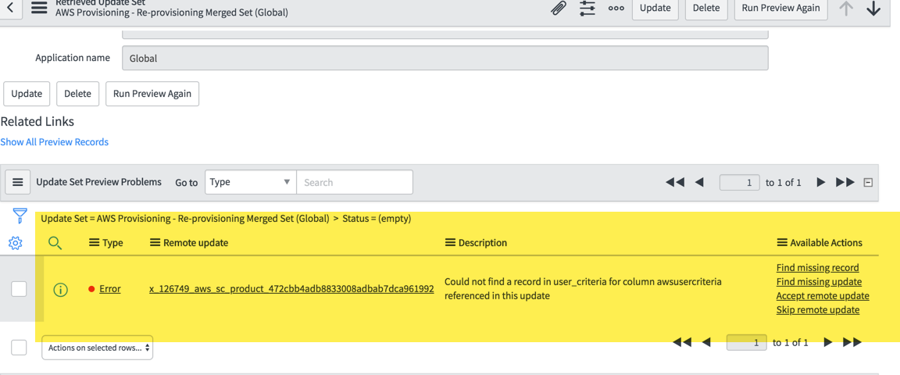

Please click on “Skip remote update”, to ignore error while previewing the update set. Or if you have already accepted the update, please make sure to change the workflow individually for you catalog item, for which you want to implement this functionality.

Rollback/Backout Update set:

* Navigate to the local update sets, find the update sets that you want rollback/backout.
* Open the uploaded update set, you will see a UI Action in top navbar “Back Out”, click on it, and it will show a pop-up message to re-verify if you want to backout the update set or not.
* Click on “Proceed with backout” to remove all the functionality that was configured with current selected update set.